Four Key Exercises:

- Pushup (Ladies - start your pushup with knees on the ground - and they stay there until you are strong; pushup against the wall also good starting place = WALLUPS)
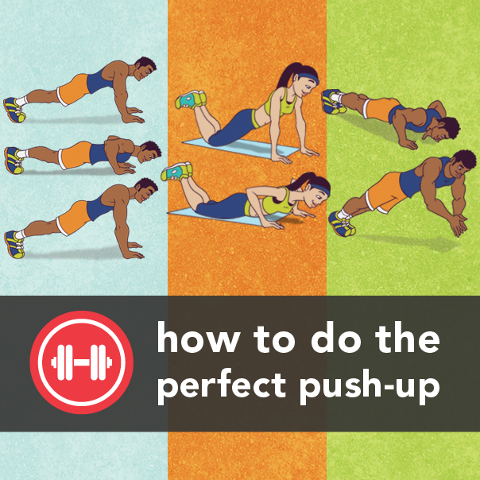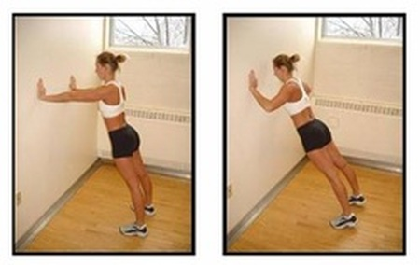
Squat

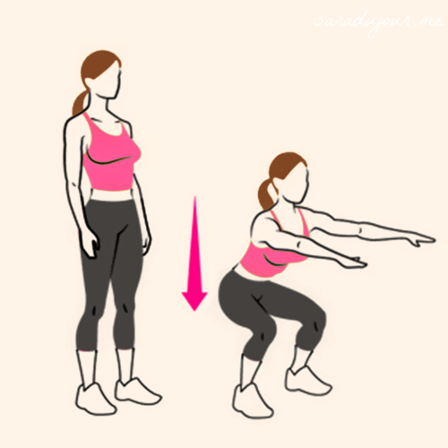

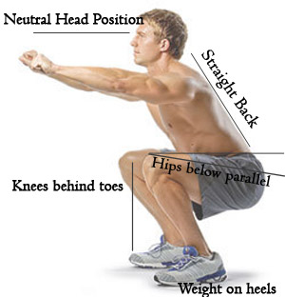

​
​
Lunges

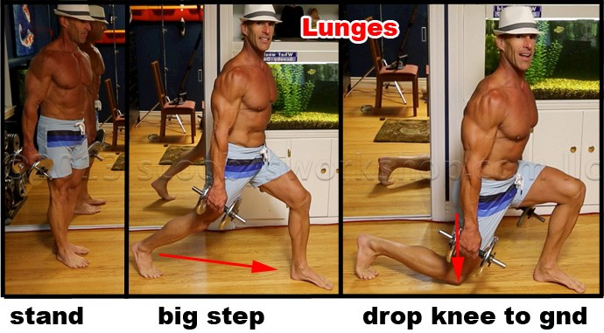

You do not have to wear a hat and you do not have to get rid of the clothes to be effective. You could do this in a suit!

Make sure that your front knee never goes moves past your front foot.

​

Exercises for start: 1 pushup, 1 squat and 1 lunge (repeat 6 times throughout the day). The key is to get into a regular pattern of exercising. On the second day you will do 2 of each repeated six times during the day and increase this daily by one until you get to 6 of each exercise per day repeated six times – so you will do 36 pushups in the day and 36 lunges on the one leg, 36 lunges on the other leg, 36 squats per day.

This you will increase on a weekly basis so that you could then later do 102 pushups a day etc

You will start with these three exercises and then with planking as well (more detail on next page)

Planking:

Here you will start with 10 seconds per day and increase this by 5 seconds every day. If you are struggling stay a few days at the previous level before you move on.

After the first week you will increase this time weekly until you get to two minutes (120 seconds) comfortably. The ideal target is to go to five minutes of planking.

Be careful if you have a fragile back, but do make sure that you strengthen your core.

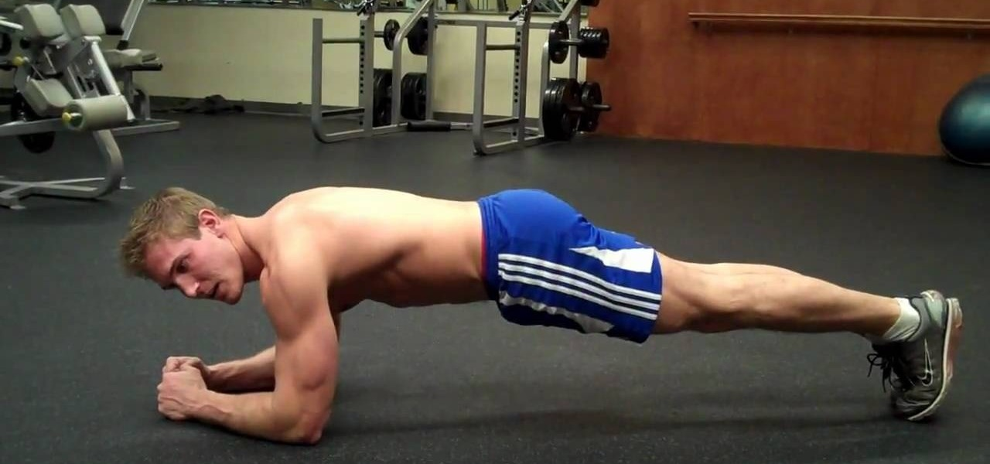

Key Exercises Reporting Table

Plank | Left lunge | Right Lunge | Push up/Wall up | Squats

Use this table to print out and fill in your details here to show your progress for yourself

This is for seven days.

